**PDO METHODS ACTIVITY**

**NAME: Montemayor, Charles David A.**

**SECTION: UCOS 3-1**

**INSTRUCTIONS.**

* In case “MySQL has stopped working” is observed, please refer to the link given below.
  + <https://docs.google.com/document/d/1_IyDLiGfhiDxisWDK6qH4BacsZPKpvgybjHtN7IBkyA/edit?usp=sharing>
* Utilizing the PDO methods we tackled last lecture, please show the code being asked below. Please keep in mind that the **data model you submitted** last **prelim** exam will be **used for the activity** today.
* Create an SQL code for its schema and records. After writing the SQL code, fill in the given details below. Don’t paste the code in plain text. Please screenshot them and paste on the space provided.
* Please save your codes in a GitHub repository. The more complex an SQL query is, the higher the points for this activity.

1. **SCHEMA + DATABASE RECORDS**

[*https://github.com/foshoo0/3rdyrprelim_projfinal*](https://github.com/foshoo0/3rdyrprelim_projfinal)

1. **SHOW CODE OF YOUR DBCONFIG.PHP FILE**

*Paste a screenshot of code here. Please add necessary comments to the code*

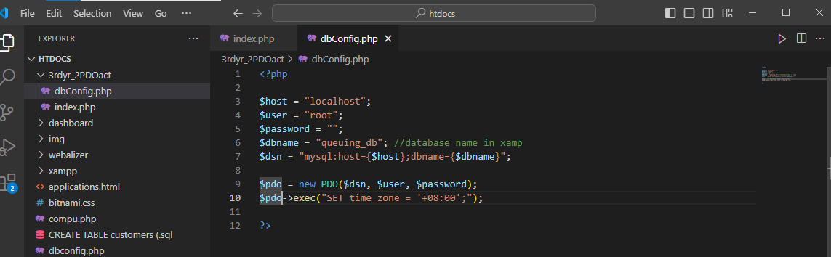

1. **SHOW CODE DEMONSTRATING FETCH_ALL(). USE PRINT_R(). WITH “<pre>” TAG IN BETWEEN.**

*Paste a screenshot of code here. Please add necessary comments to the code*

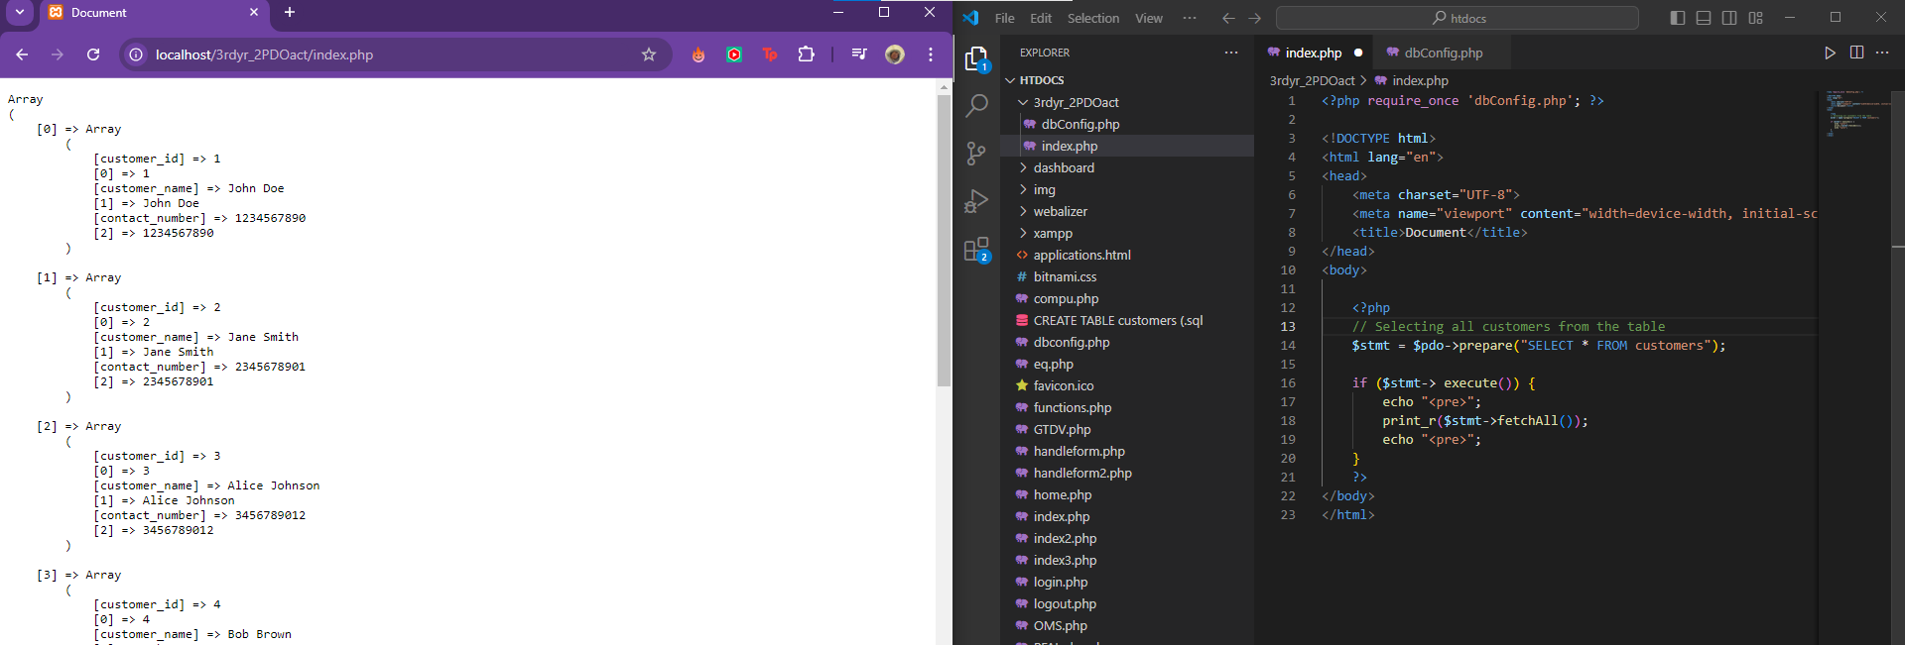

1. **SHOW CODE DEMONSTRATING HOW FETCH() IS USED. USE PRINT_R(). WITH “<pre>” TAG IN BETWEEN.**

*Paste a screenshot of code here. Please add necessary comments to the code*

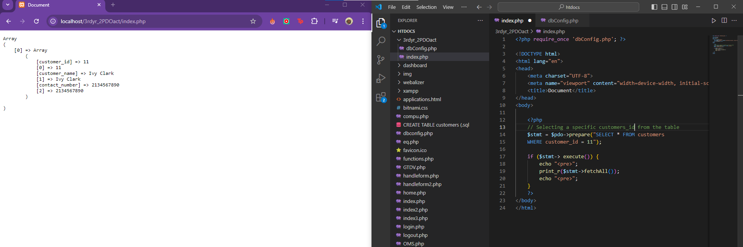

1. **SHOW CODE DEMONSTRATING INSERTION OF RECORD TO YOUR DATABASE**

*Paste a screenshot of code here. Please add necessary comments to the code*

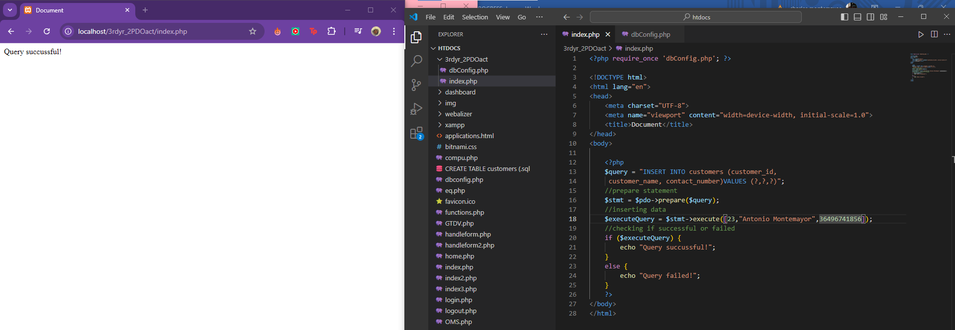

1. **SHOW CODE DEMONSTRATING DELETION OF RECORD TO YOUR DATABASE**

*Paste a screenshot of code here. Please add necessary comments to the code*

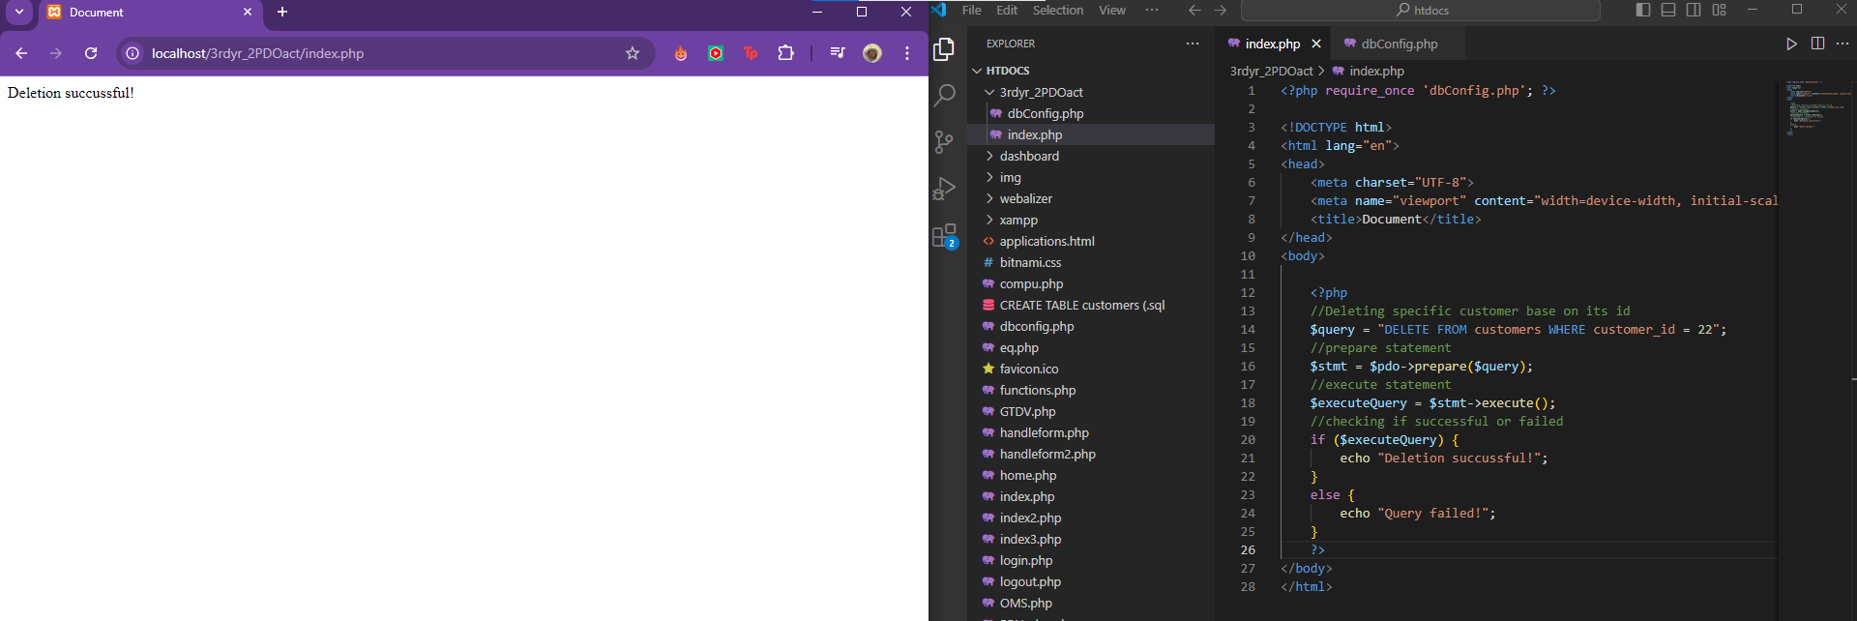

1. **SHOW CODE DEMONSTRATING UPDATING OF RECORD FROM YOUR DATABASE**

*Paste a screenshot of code here. Please add necessary comments to the code*

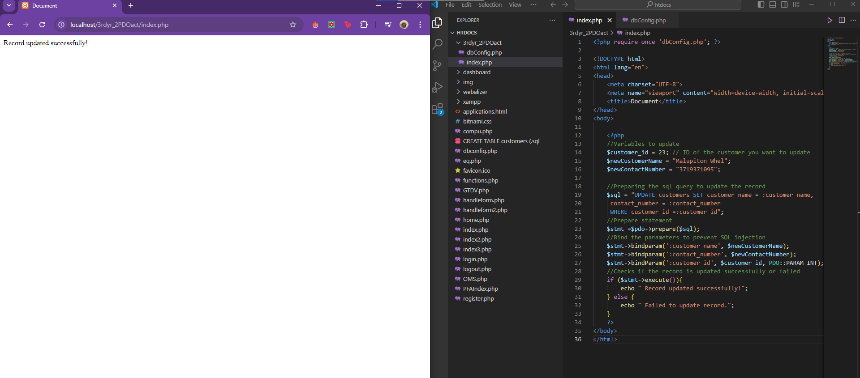

1. **SHOW CODE DEMONSTRATING AN SQL QUERY’S RESULT SET IS RENDERED ON AN HTML TABLE**

*Paste a screenshot of code here. Please add necessary comments to the code*

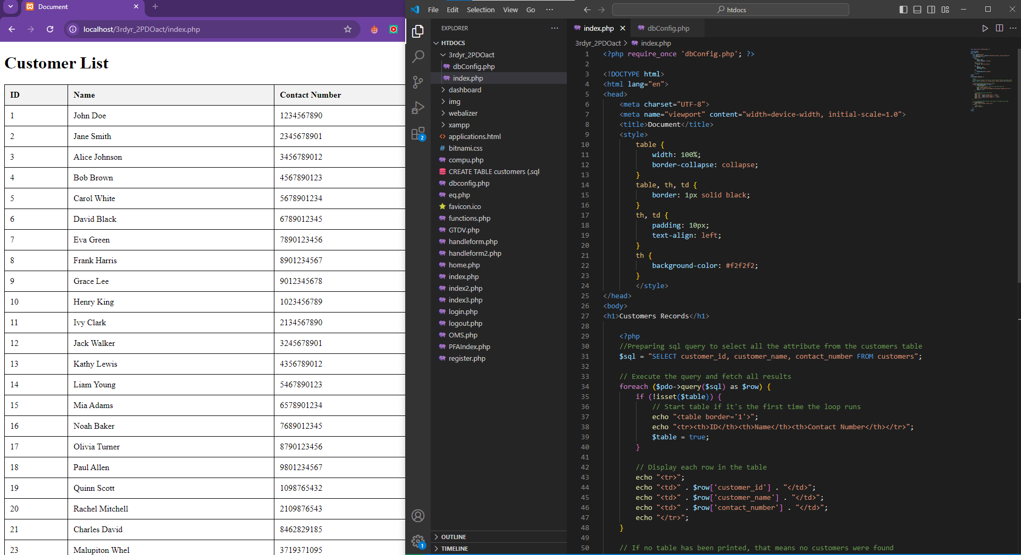

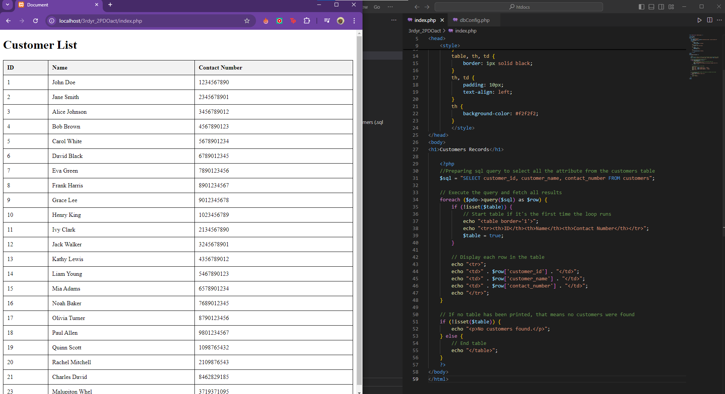

**GITHUB LINK TO ACTIVITY:**

*Paste GitHub link of repository here where you did the activity.*

[*https://github.com/foshoo0/3rdyr_PDO_dbconfig_phpact*](https://github.com/foshoo0/3rdyr_PDO_dbconfig_phpact)